User manual and installation instruction for application for measuring length of fish using hand-held camera

Tore Johannessen

Institute of Marine Research

Norway

[torejo@hi.no](mailto:torejo@hi.no)

This user manual describes both placement of the fish on the measuring board and installation and use of the Fish-Meash app.

Field work

1. The fish must be placed on the board with the snout towards the sidewall and the body stretching ca. 90° out from the wall. This fish can also be placed with the snout towards the mid-line of the board (or drawn lines parallel to side walls) with the body ca. 90° out from the line. If placed along the mid-line, precise placement is important to obtain accurate measurements. If the fish is bent, the fish must be placed with the oval side upwards to ensure that the tail is touching the board (explanation below). Smaller fish (e.g., 0-group) and smaller organisms without tails like shrimps and mussels (“parallel organisms”) can be placed randomly on the board or a rectangular sheet of paper or plastic.
2. The photo should be taken close to the centre of the board and all four corners must be visible. Out of centre measurements will also provide precise estimates, but close to centre photos will be better for later use, for example estimates of individual weight of the fish using length-area-weight relationships (planned to be implemented in future versions of the app). Photos of smaller organisms placed randomly on the board should be taken at some distance (e.g., >100 cm) and zoomed in. The theoretical error of the measurements can be estimated using the Excel-file “Error of measurements” found in the same folder as the app. The error depends on how much the organisms are extending out of the board (hight), distance from scenter line of the camera and the distance between the camera and the board (see drawing below). This is not relevant for fish placed with the snout towards the sidewalls or along the mid-line.

(Drawn to be inserted)

Installation and use of app

1. Download app and photos to your computer, e.g., to the C-drive. Do not use special characters in the name of the app-folder or folders or photos (e.g., the Norwegian letters æ, ø and å; this is only relevant for Windows users).
2. Run app as normal by double-clicking.
3. Upload photo by clicking «Browse File» in upper left corner. If the photo cannot be opened, check the format of the photo, and convert to JPEG, TIFF or PNG if necessary. Photo can be rotated by clicking the two arched arrows.

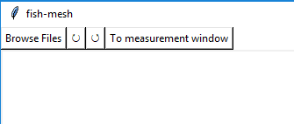

1. If not all four corners of the board are visible, click on the square in the upper right corner (encircled in red below).

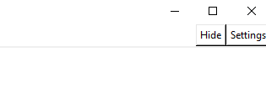



1. Click on “Settings” in the upper right corner of the screen and specify dimensions of the board. Use decimal point if relevant. In the “Settings” window there are also several other options. “Measure box margin percentage” specifies the size of the margin around the straightened window, “Font size” to be used in the measurement window, “Point size” of start and end points of the measuring line, and “Draw color” sets the preferred colour to be used in measurement window. Settings can be saved for future sessions.

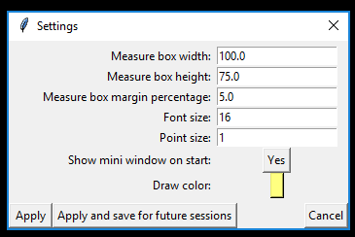

1. In the uploaded photo, a drawn rectangle will appear. Move the corner points of this this rectangle to the corners of the board as seen in the figure below. Be precise as this will impact the accuracy of the measurement. If the mini-window in the upper right corner of the screen is hiding corners of the board, click “Hide” just above the mini-window. It can also be hidden in the “Settings” window (see fig. under section 5).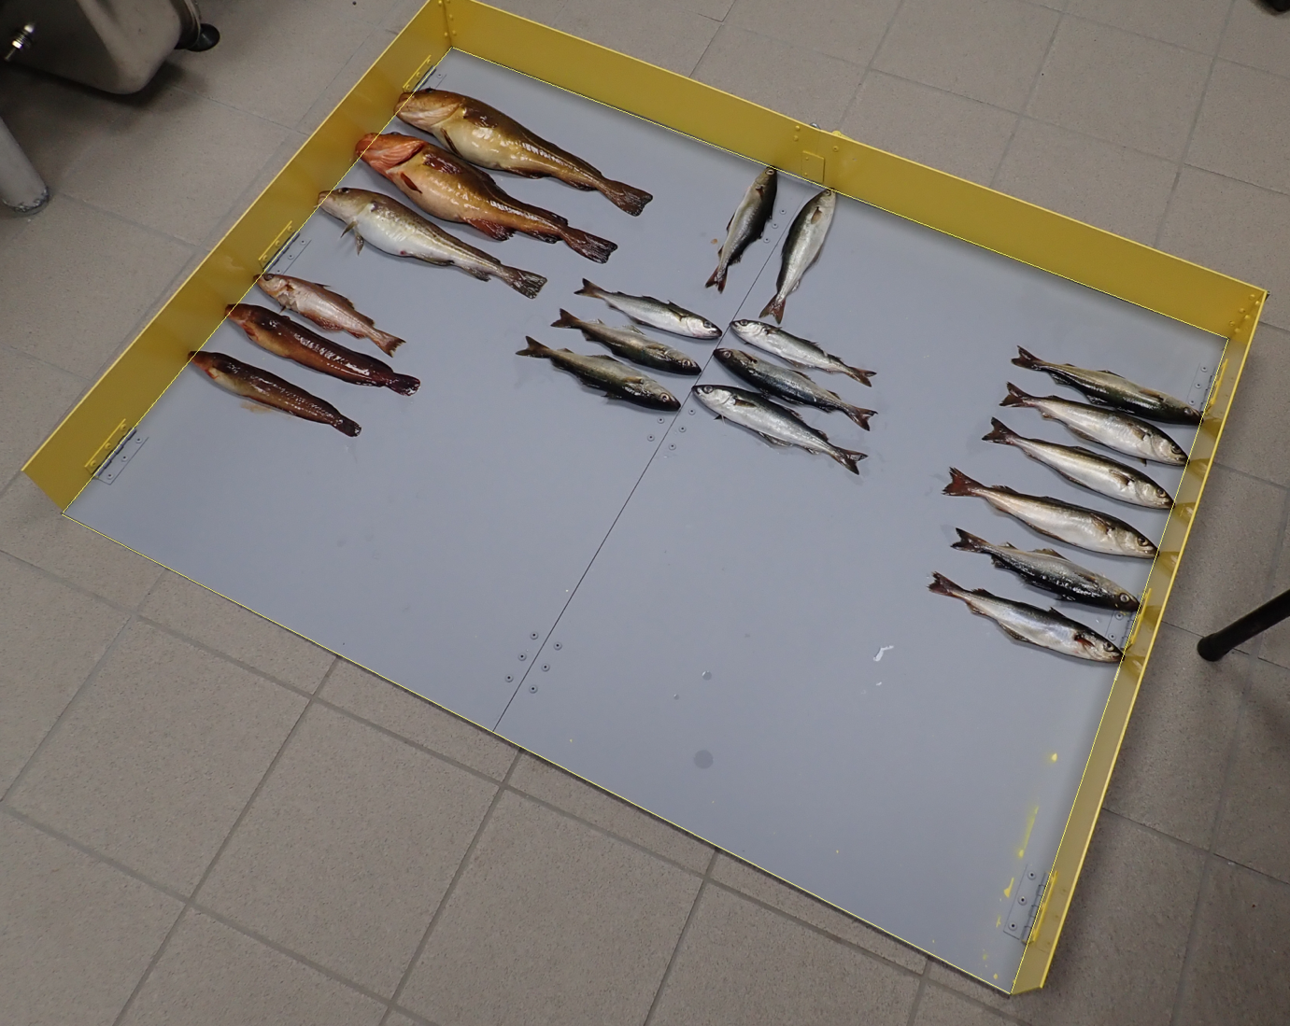

Drawn rectangle

Drawn rectangle

1. Click on «To measurement window» in upper left corner. The photo in the measurement window is straightened and pixels adjusted to allow precise measurements of fish. Check if the drawn rectangle has been placed precisely in the corners of the board. If not, return to the drawing window by clicking «Back to drawing window» in the upper left corner of the screen and adjust rectangle before returning to measurement window.

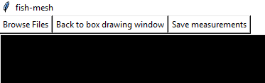

1. Fish is measured by clicking on the tail and outside the drawn rectangle as the measurement point is adjusted to the drawn rectangle (the edges of the board) automatically. Follow the centre line of the fish when measuring fork length (the measuring line is shown on the screen). Measurement points can be adjusted by click-lock (click and hold) and move. Right-click on one of the measuring points will delete the measurement of the selected fish.

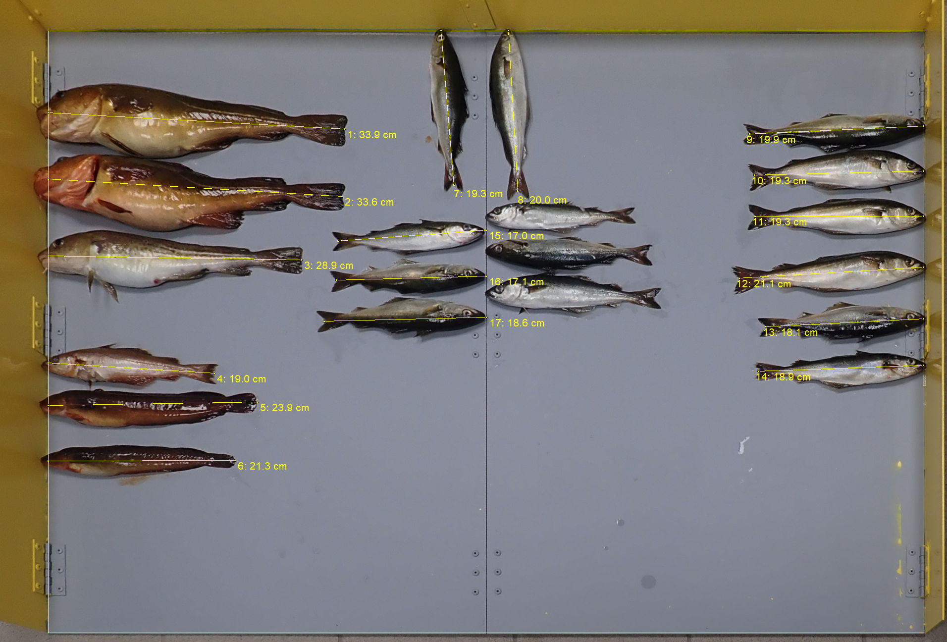

Photo after straightening. Measurements are numbered sequentially followed by the length of the fish (e.g., 1: 39.9 cm), 2: 33.6 cm).

It is recommended to measure fork length as it is easy to follow the centre line of the fish. If measuring total length, draw the line parallel to the centre line of the fish (see below)

Measurement of fork length:

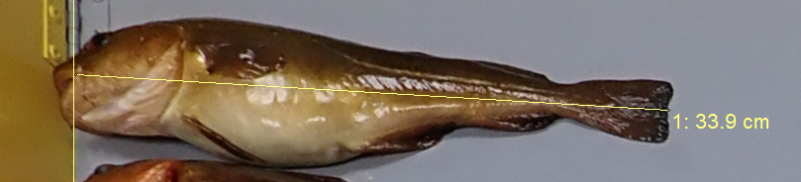

Measurement of total length:

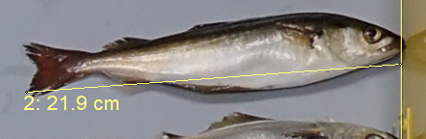

When measuring fish placed along the mid-line of the board, click on the tail and on the mid-line (not the snout).

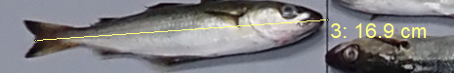

1. Measurements are saved by clicking «Save measurements» in the upper left corner of the screen. Data are saved to an Excel-fil and the photo of the measurements as a JPEG-file. Default names of the files are date and time when the photo was taken, with D- in front of the data file and P- in front of the picture-file. Date and time are obtained from the metadata of the original photo. If the camera has a GPS, position where the photo was taken is stored in the data file. If users specify their own file name, the same name will be used for the data and photo file preceded with a D- and P-, respectively. In the Excel-file, the names of the species must be entered. If the species are place in sequence on the board, the name only needs to be written once as it can be copied to the other specimens by the “fill down” function. If species have not been placed in sequence on the board, one can measure species by species to avoid writing the species name more than once (see photo below).

